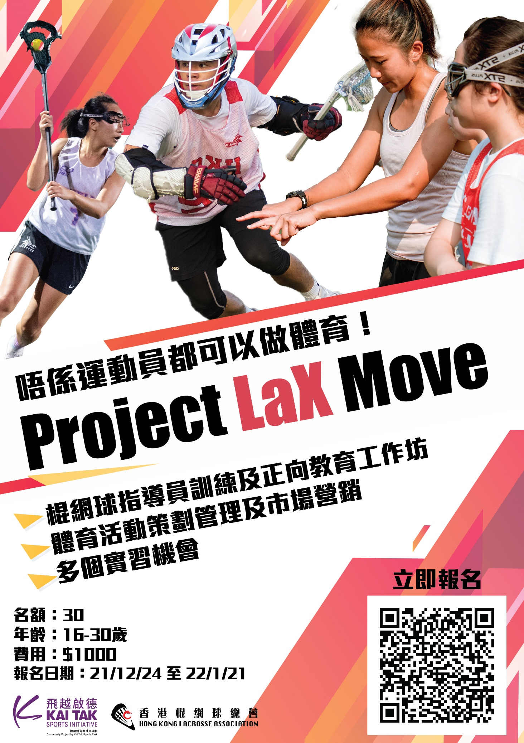
Project LaX Move
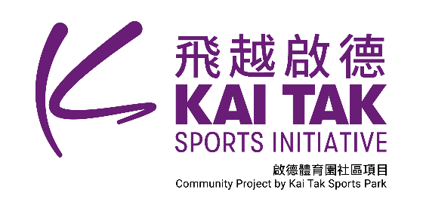
The programme is designed for 16-30 aged young enthusiasts who aspire to pursue a career in the sports industry. It aims to equip the potential talents with holistic experience in sports, leisure and recreation organisations such as; sports marketing, sports event management and positive coaching. Moreover, the programme offers certifications which can equip participants with lacrosse specific skills and qualifications for a potential career with HKLA - HKLA Lacrosse Senior Instructor.

Objectives
- Equips participants with different skills related to sports, leisure and recreation
- Provides holistic and hands on event experience at a National Sports Association
- Provides professional instructions from different sports organisations and companies
- Offers internship and other opportunities at recognized sports organisations or companies

Need Assessment

Project LaX Move would be a career development program for youth to empower themselves and discover their abilities in sport industry. Project LaX Move contains diversified topics to educate students about sport marketing, sport event management and positive coaching which will be applied in sport industry. HKLA would like to use sport to build up youth’s character and their confidence in a way to pursue a career in the sports industry. Internship opportunity in Project LaX Move provides chance for youth to earn the valuable experience and get well prepared in sport industry. Besides, participants can take lacrosse as career path since we can provide the lacrosse instructor course. Expanding our game to the general public, we are keen to promote lacrosse in primary and secondary school through fun day or school lacrosse demonstration. As a result, we can provide plenty of opportunities for instructors to assist our activities. Moreover, if participants are interested in coach development, we can provide level 1 lacrosse development coach course and further study in coaching development. It would be a sustainable development program for participants to learn lacrosse and help other to learn in furture. We believe the comprehensive training of Project LaX Move can help participants to equip themselves with fruitful experience and build up the confident. Furthermore, it can create positive value and hopes in community.

Course structure
Project LaX Move is designed as a 4-month career development for the youth to discover their talent. We target for 30 students for each phase and planning for 3 year with 2 phases per year. Underprivileged students will have a priority to participate in. Project will be held on Sunday since February 2022 and July 2022. The purpose of the project is to unleash teenagers’ talent and lead them a promising career at Hong Kong Lacrosse Association with the following program details:
Date | Time | Course | Location | Content
6 Feb 2022 | 10am - 1pm | Introduction | Classroom session | - Lacrosse & Project Lax Move introduction  - Recruitment, Job and Programme Application in the Sports Industry
13 Feb 2022 | 10am - 1pm | S&C and Lacrosse | Field session | - Students can experience the lacrosse game on field and gain the knowledge of S&C through practical practice.
20 Feb 2022 | 9am - 1pm | Lacrosse Instructor course | Classroom session + Field session | - To teach students to become a certificated instructor who can demonstrate and instruct beginners to Lacrosse on the fundamental knowledge and skills of the game.
27 Feb 2022 | 10am - 1230pm & 2pm - 430pm | Positive Education | Classroom session | - To understand about positive education and provide the tool of developing and applying positive education
6 Mar 2022 | 10am - 12pm | Lacrosse coaching for NGOs | Field session | - Students can experience the coaching of lacrosse.
13 Mar 2022 | 9am - 1pm | Elementary First Aid Course (EFA) | Classroom session | - This course contents include basic first aid theory, immediate management for accidents
20 Mar 2022 | 10am - 11:30am | Lacrosse experience | Field session | - Students can experience the lacrosse game on field.
27 Mar 2022 | 10am - 11:30am | Lacrosse experience | Field session | - Students can experience the lacrosse game on field.
10 Apr 2022 | 10am - 12pm | Lacrosse coaching for NGOs | Field session | - Students can experience the coaching of lacrosse.
17 Apr 2022 | 10am - 5pm | Lacrosse competition – Hong Kong Lacrosse Open 2022 | Field session | - To teach students how to plan and run a lacrosse competition  - Students will be divided into different teams and take the responsibility for different positions in competition preparation
24 Apr 2022 | 10am - 1pm | Sport marketing & event management | Classroom session | - To teach students how to plan, coordinate and develop a marketing proposal based on the principle and knowledge of the sports marketing.  - To provide students the general overview and practical experience in event management including planning and preparation of event, sponsorship and risk management.
1 May 2022 | 10am - 1pm | Preparation for 15/5 event day | Classroom session | - To prepare the event with applying in sport marketing and event management knowledge.
8 May 2022 | 10am - 1pm | Preparation for 15/5 event day | Classroom session | - To prepare the event with applying in sport marketing and event management knowledge.
15 May 2022 | 1.5 hours | Event day - Junior Lacrosse Tournament 2022 (Spring) | Po Tsui Park | - To coordinate the event.

Benefits
Talented students will have a chance to be selected as assistant of HKLA main event.
Students must have 80% attendance to obtain the following certification:
- Participation Certificate of Project LaX Move
- Hong Kong Lacrosse Association Instructor Certificate (must attend instructor course)
- Elementary First Aid Attendance Certificate from Hong Kong Red Cross (must attend elementary first aid course)
- Participation Certificate of positive education workshop (must attend positive education course)
- A t-shirt of Project LaX Move

Coaches Development Pathway
Qualification Levels | Level Descriptors
Lacrosse Instructor | A certificated instructor can demonstrate and instruct beginners to Lacrosse on the fundamental knowledge and skills of the game with a certificated coach.
Senior Lacrosse Instructor | A certificated instructor can lead a demonstration event and instruct beginners to Lacrosse on the fundamental knowledge and skills of the game alone.
Level 1:  Lacrosse Development Coach | A recognized Level 1 coach can support a program or lead its unit with the focus in developing the players’ skills effectively. Can apply for coaching work at Development Academy level.
Level 2:  Lacrosse Performance Coach | A recognized Level 2 coach can lead a program of competitive levels and develop the players into athletes and effectively perform as a team. Can apply for coaching work at U19 HK Representative team level.
Level 3:  Lacrosse High Performance Coach | A recognized Level 3 coach can lead and develop the athletes of highly competitive levels and drive the players and teams to excel and sustain in high performance. Can apply for coaching work at HK Representative team level.

Coaching opportunities
Lacrosse players in Hong Kong has a clear pathway to excel in their prime time. HKLA has routine training every week for Representative Teams, HPP Teams, Development Academy and U19 Teams. HKLA will send teams to attend World Championships every year according to tournament schedule.
Since 2018, HKLA has joined the LCSD Subvention scheme to provide different level of lacrosse introduction course to public. We would be delivering 60 class a year in different district.
Both primary school and secondary school team will prepare weekly for the annual Interschool Lacrosse Competition. In 2019, there are 11 primary schools and 13 secondary schools joining.
Other than schools, HKLA has partnered with different NGOs, brands and private clubs to provide fun days, lacrosse demonstrations and promotional campaigns throughout the whole year. For example, Friesland Campina, BGCA, Playground Association and Club De Recreio.

